**LECTURE-1 : Professionalism**

**What is Professionalism?**

* It is the conduct, behavior and attitude of someone in a work or business environment
* Professionalism leads to workplace success, a strong professional reputation and a high level of work ethic and excellence.
* The employee's ability to embody the company's values and do what their employer expects of them
* Professionalism is necessary for the long-term success of any business, large or small
* It ensures that customer relationships are maintained, employee interactions are positive and that a company meets its goals and objectives
* Professionalism includes standards of behavior for the employees

**EXAMPLE:**

* In a recent study on Career Readiness conducted by NACE (National Association of Colleges and Employers), employers who hire college graduates were asked which professional competencies were essential to workplace success. Professionalism/work ethic topped the list with 97.5% of respondents identifying it as either “absolutely essential” or “essential” for a new college hire’s success
* Project a professional presence and dress appropriately for your industry and organization. A good rule of thumb is to dress in the position you aspire to have
* Prioritize, plan and manage your assignments and projects
* Professional is not a label you give to yourself, but a description, you hope others will give of you

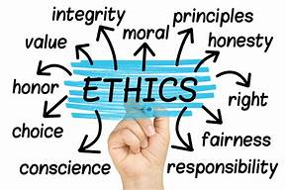 

CHARACTERISTICS OF A PROFESSIONAL

* Committed
* Considerate
* Cooperative
* Courteous
* Dependable
* Honest
* Reliable
* Skilled

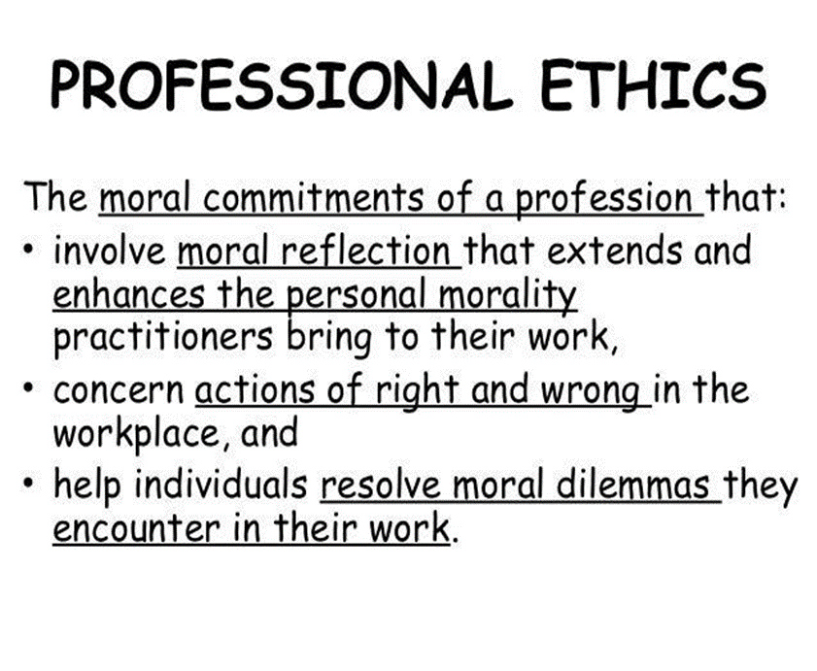**LECTURE-2 : Professional Ethics**

**What is Professional Ethics ?**

* Ethics is the reasonable obligation for us to refrain from hurting others, and sometimes an obligation to help others
* Professional ethics refers to the personal code of conduct that one is expected to uphold in a workplace, as well as the ethics of the organization and industry that he or she works for
* It encompass the personal and corporate standards of behavior expected by professionals
* Professional ethics concerns the moral issues that arise because of the specialist knowledge that professionals attain, and how the use this knowledge should be governed when providing a service to the public
* Anyone who promises to deliver and delivers as promised without giving up his/her own values is a professional.
* Professional ethics is about the code of conduct on moral issues pursued by persons sharing the same skill, trade or occupation.

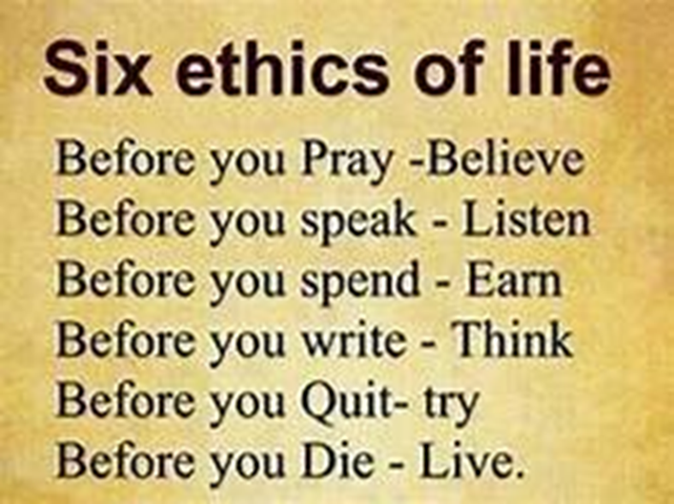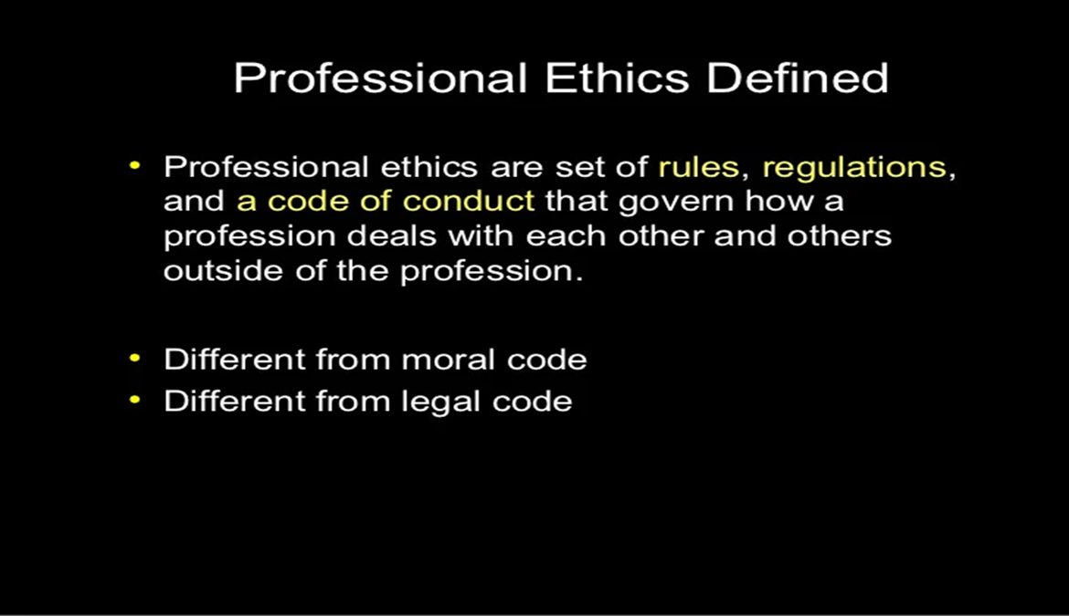

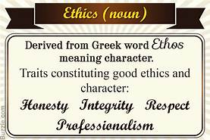

**ENGINEERING ETHICS**

* Conflict Resolution
* Creativity
* Cultural
* Empathy
* Integrity
* Perspective
* Stewardship
* Codes of professional ethics are established in order to provide guidance to professionals, usually to not abuse client relationships and preserve the integrity and reputation of the applicable profession
* Professional ethics are standards set by professional organizations for the behavior and values of people working within a specific field

1. 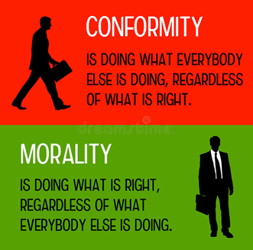**Morals**

* A lesson that can be derived from a story or experience; Standards of behavior; principles of right and wrong
* Moral refers to what societies sanction as right and acceptable
* Morals are rules set by the society
* 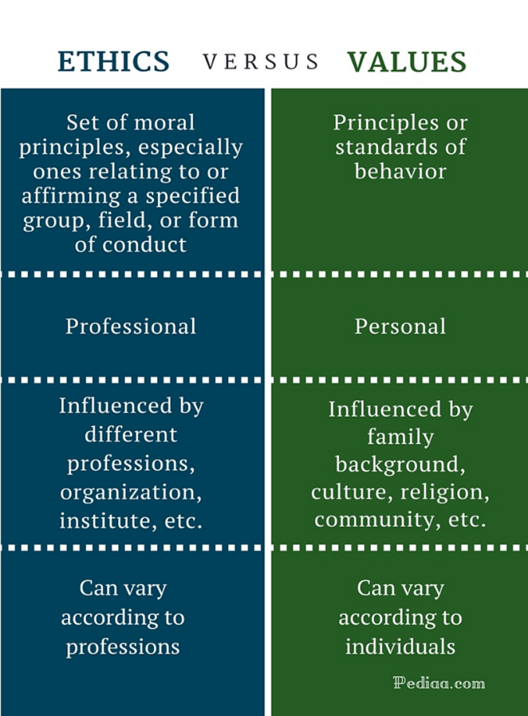Moral behavior is extremely subjective, but it is generally represented by an individual's knowledge of social and cultural norms and the capacity to perform good works through selfless actions. Some moral behaviors may include honesty, giving to charity and avoiding negative situations

1. **Values and Ethics**

* Values are subjective; they’re personal or organizational, not societal, and they vary tremendously from one person to another, and from one company to another
* Ethics are essentially a guiding principle that help us choose between right and wrong, but “right” and “wrong” aren’t absolutes

1. **Integrity**

* Integrity is being one, being close nit, being firm
* A state of being whole and undivided
* **Honesty -**Being honest is being truthful
* **Sincerity -**Sincerity is doing your work to the best of your ability

**Integrity**

* Honesty
* Trust
* Fairness
* Respect
* Responsibility
* Courage
* Integrity means that there is coherence between what you say, what you do, what you think, and how you feel about life around you.
* Integrity is the practice of being honest and showing a consistent and uncompromising adherence to strong moral and ethical principles and values

1. **Work Ethics**

* It is a plus for achieving a successful career. **Appearance is one work ethic that really shows**
* Holding key traits such as attendance, character, teamwork, appearance, and attitude add value to both you as a person and your company.
* Combining work ethics with professional skills invites success to a celebration, and that celebration is all about you.
* A professional attitude towards yourself and your chosen career is critical**.**

**LECTURE-3 : Engineering Ethics**

**Engineering** is the process of developing an efficient mechanism which quickens and eases the work using limited resources, with the help of technology.

**Ethics** are the principles accepted by the society, which also equate to the moral standards of human beings. An engineer with ethics, can help the society in a better way.

Hence the study of **Engineering Ethics**, where such ethics are implemented in engineering by the engineers, is necessary for the good of the society.

***Engineering Ethics*** is the study of decisions, policies and values that are morally desirable in engineering practice and research.

***Engineering Ethics*** is the set of rules and guidelines that engineers adhere to as a moral obligation to their profession and to the world. Engineering is a professional career that impact lives.

1. **Service Learning**

* Service learning is an education and youth development strategy that connects learning objectives with meaningful service to the community
* It is a methodology falling under the category of experiential education
* Students build civic, leadership, and academic skills while strengthening communities through service
* Service learning refers to learning the service policies, procedures, norms, and conditions, other than the technical trade practices
* Benefits include improved academic achievement, increased student engagement and civic skills, and stronger communities
* Through service-learning, young people—from kindergarteners to college students—use what they learn in the classroom to solve real-life problems

1. 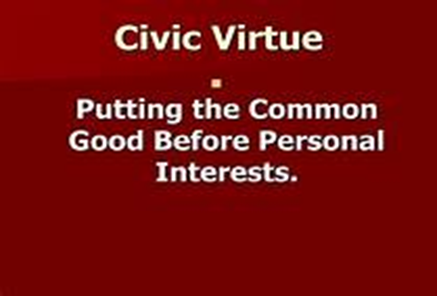**Civic virtue**

* Civic virtue is morality or a standard of righteous behavior in relationship to a citizen's involvement in society.
* They are the moral duties and rights of the individual, as a citizen of the village or the country or an integral part of the society and environment.
* It is the dedication of citizens to the common welfare of their community even at the cost of their individual interests.
* An individual may exhibit civic virtue by voting, volunteering, organizing welfare groups and meetings
* Some important **concepts that help constitute civic virtue** are:
* 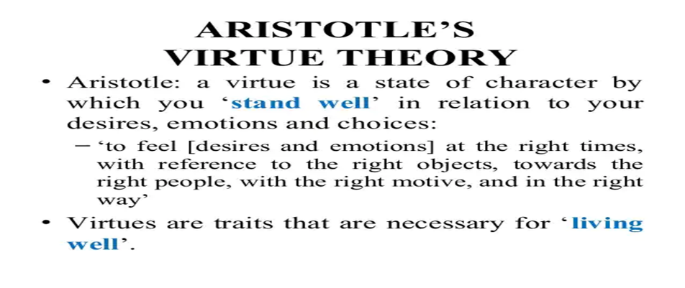***Self-sacrifice***: Putting the needs of a community over one's own needs is one of the most deeply rooted parts of civic virtue.
* ***Participation*** in government and in the community is part of what makes one a good citizen.
* ***Doing one's part:*** The idea of civic virtue is that each individual has their own duties that help make society function as well as possible.
* ***Cooperation:*** Being a cooperative member of society, obeying the law, and working well with others are some of the things that proponents of civic virtue promote

1. **Respect for others**

* Respect is a positive feeling of admiration or deference for a person.
* Whether in personal relationships with others, or in a company, being polite and well-mannered pays off in many ways
* In your personal life, remembering special days, holding doors, and displaying good manners in general, shows respect for the other person. That respect will almost always be reciprocated by the other person
* Polite and respectful actions are a sign of self confidence
* Service implies an equal respect for yourself and others

***What does respect mean? How do you show respect?***

* 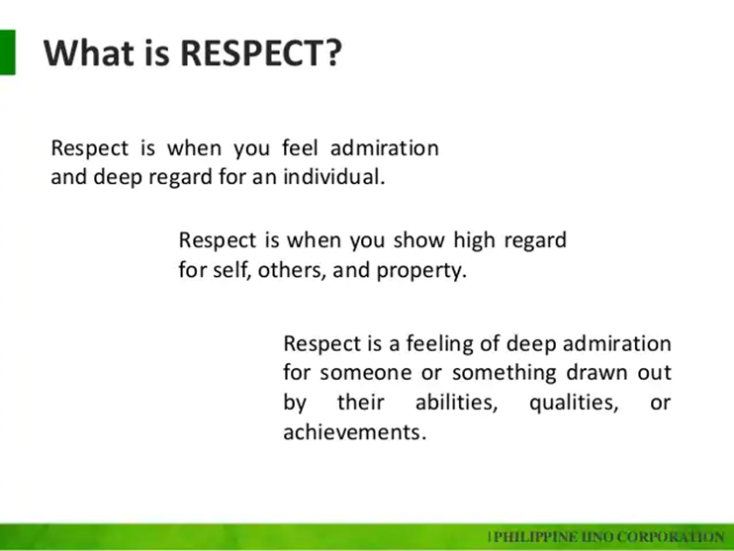Being polite and courteous
* Treating others fairly
* Being honest
* Keeping appointments
* Not barging past lineups
* Remembering special days
* Holding doors
* Genuine concern for the rights and feelings of others

1. **Living Peacefully**

***Factors that promote living, with internal and external peace:***

* Conducive environment (safe, ventilated, illuminated and comfortable)
* Secured job and motivated with ‘recognition and reward’
* Absence of threat or tension by pressure due to limitations of money or time
* Absence of unnecessary interference or disturbance, except as guidelines
* Healthy labor relations and family situations
* Service to the needy (physically and mentally-challenged) with love and sympathy

**LECTURE-4 : Engineering Ethics**

***The prime objective of knowing and prescribing Human Values are as follows:***

1. To understand the moral values that ought to guide the engineering profession
2. To create an awareness on Engineering Ethics and Human Values
3. To inspire Moral and Social Values and Loyalty
4. To appreciate the rights of others
5. Resolve the moral issues in the profession
6. To justify the moral judgment concerning the profession
7. Intended to develop a set of beliefs, attitudes, and habits that engineers should display concerning morality

***The prime objectives of Professional Ethics are as follows:***

1. Moral awareness (proficiency in recognizing moral problems in engineering like plagiarism and patenting )
2. Convincing moral reasoning (comprehending, assessing different views)
3. Moral coherence (forming consistent viewpoints based on facts)
4. Moral imagination (searching beyond obvious the alternative responses to issues and being receptive to creative solutions)
5. Moral communication (to express and support one‘s views to others).

***CARING***

* Caring is the process of protecting someone or something and providing what that person or thing needs.
* Caring means attention to detail.
* You care about what you do and make an effort to do your best E.g. If you care about my health you see that things you do are good for me
* When you care, you put in that extra effort to make sure that what you do works for you or for whoever or whatever you are doing it for
* Caring is feeling for others.
* It includes showing respect to the feelings of others.
* Caring is reflected in activities such as friendship, membership in social clubs and professional societies, and through various transactions in the family, fraternity, community, country and in international councils

***How can you be caring?***

*Whatever you do, whether its production, invention, creation or construction, you should be consciously aware about the effect it will have on people who are going to use it and on you. It is your responsibility to see that you are safe and others are safe*

***SHARING***

* Sharing is the joint use of a resource or space
* It is the process of dividing and distributing.
* It refers to joint or alternating use of inherently finite goods
* A knowledge-sharing culture is a corporate culture which encourages and enables the free exchange of knowledge, insight and experience in order to benefit individuals and drive a business toward key strategic goals

***Creating a Knowledge-Sharing Culture***

* Encourage Team Bonding
* Employ Virtual Rewards for Sharing Incentives
* Offer Real-Life Rewards
* Let Employees Know the Value of Their Knowledge
* Identify and Capitalize on your Knowledge Experts
* Include Them as Job Requirements
* Personalize Your Training Program

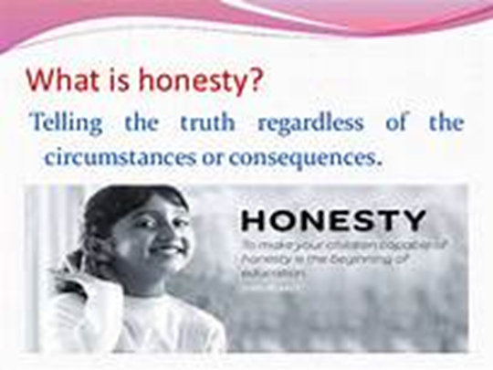***HONESTY***

* Honesty is being truthful to oneself
* Honesty is being fair and straight forward
* Honesty is being loyal
* Honesty is being reliable
* Honesty is speaking facts
* Honesty is not saying things about people that are not true

***Why should you be honest***

* It underpins trust in a relationship
* It almost always leads to the best outcomes in the long run
* Telling the truth is simple
* It is better for your mental health / inner peace
* It is good for your self-esteem
* Being honest may not get you many friends, but it will always get you the right ones

***COURAGE***

* Courage is the ability to do something difficult even when there's risk
* Courage is doing and saying what they think is right despite opposition
* Courage is the choice and willingness to confront agony, pain, danger, uncertainty, or intimidation
* Mental or moral strength to venture, persevere, and withstand danger, fear, or difficulty
* Courage is not absence of fear, but triumph over it

***Why should you be courageous***

* *Increases confidence level:* courage boosts your confidence and enables you to take on huge projects. When you are courageous, another person will require a lot of energy to bring you down
* *Propel you to greater heights:* employers, sponsors, and other organizations look for, hire and even promote courageous people. It can be an avenue for your breakthrough in life
* *Promotes spiritual growth:* the more you exercise courage, the more your fear disintegrates. Eventually, you will attain inner maturity necessary for spiritual growth
* *Gives you experience:* courage enables you to take chances that you otherwise would not, and when you repeatedly execute the task your experience grows

**LECTURE-5: Soft Skills**

***What is TIME***

* Time is the measured or measurable period during which an action, process, or condition exists or continues
* It is a non-spatial continuum that is measured in terms of events which succeed one another from past through present to future
* It is not something we can see, touch, or taste, but we can measure its passage

Time is a rare resource, which, once spent, is lost forever Time is a commodity you can’t afford to waste in life. Everything created by God has an expiry date. “A time to be born and a time to die.”

* To be successful and great in life, one needs to respect and value time.
* Most often than not, people who waste and don’t value time never achieve anything successful in life

***Why should you Valuing Time***

1. ***Prevents Putting Things Off***

The valuing of time helps to prevent putting things off. Putting things off is theft of time and success. It is vital that, we spend time to work on the tasks or goals wisely. There is no need to want to achieve all the goals at once. It is better to break or divide task into smaller units or portions, so that we can be able to achieve them within an allocated time frame.

1. ***Productive And Effective***

Value time because it also helps us become very productive and effective in our pursuit to our next level. We are able to exert energy to work more efficiently, gain more knowledge and experiences. Most people who respect and value time are able to learn faster and work faster. They become more focused and pay more attention to their work.

1. ***Health And Good Life.***

Each and every one of us needs time to relax and enjoy quality time with our loved ones. This can only be possible when we learn to respect and value time. Life is very busy and if we fail to value time, we will waste it on unnecessary stuffs, which may have major effects on our relationships with the people we love most.

1. ***Less Worry***

When we are able to manage our time well; we don’t get worried about things but, have better chances of improving our health because, we become less stressed about life’s challenges and achieve maximum productivity with our lives.

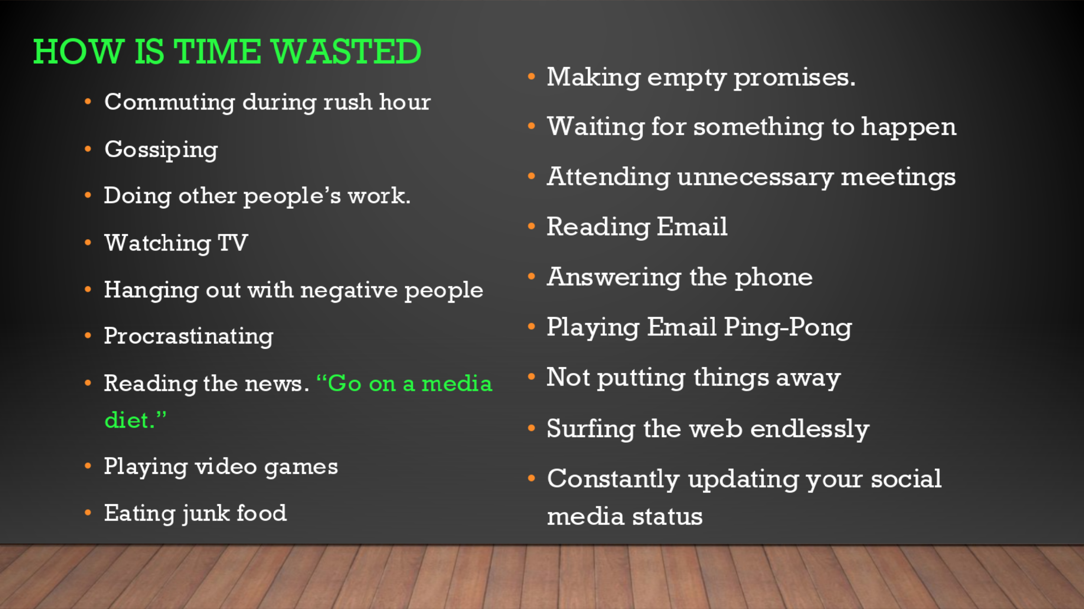

***CO-OPERATION***

* It is the team-spirit present with every individual engaged in engineering
* It is activity between two persons or sectors that aims at integration of operations
* Willingness to understand others, think and act together and putting this into practice, is cooperation
* Cooperation should exist or be developed, and maintained
* The absence of cooperation leads to lack of communication, miscommunication, misunderstanding, misinformation

***Impediments to successful cooperation are:***

* Clash of ego of individuals
* Lack of leadership and motivation
* Conflicts of interests, based on region, religion, language, and caste
* Ignorance and lack of interest

**LECTURE-6: CHARACTER**

***CHARACTER***

* The particular combination of qualities in a person or place that makes them different from others
* The character of a person or place consists of all the qualities they have that make them distinct from other people or places
* Professional characteristics refer to the qualities a person exemplifies or shows, in a business environment

Here are 15 characteristics that can help you earn the respect of others and position you for promotions: Professional characteristics

1. ***Professional appearance :***  Professionals should always strive for a professional appearance, including appropriate attire and proper hygiene and grooming. Clothing should always be clean and ironed properly. Pants, dresses, formal skirts, crisp white shirts and leather shoes are all appropriate for a professional's wardrobe.
2. ***Reliable* :** Professionals are dependable and keep their commitments. They do what they say they will do and don't overpromise. Professionals respond to colleagues and customers promptly and follow through on their commitments in a timely manner. Punctuality is a key aspect of this professional characteristic. It's always important to clarify any areas of uncertainty when dealing with customers or members of your team to ensure there are no mistaken assumptions or surprises.
3. ***Ethical behavior*** : Embodying professionalism also means to be committed to doing the right thing. Honesty, open disclosure and sincerity are all characteristics of ethical behavior. Many organizations include a commitment to ethical behavior in their code of conduct. Professionals can adopt a personal code of conduct and make the same commitment on an individual basis.
4. ***Organized :*** Professional keep their workspace neat and organized so that they can easily find items when need them. All files and paperwork should be in place and, if they have to deliver a presentation, all materials should be ready well in advance so there are no unexpected delays
5. ***Accountable :*** Just as professionals accept credit for having completed a task or achieved a goal, they also are accountable for their actions when they fail. They take responsibility for any mistakes that they make and take whatever steps necessary to resolve any consequences from mistakes. They are accountable and expect accountability from others.
6. ***Professional language :*** People who behave with professionalism monitor every area of their behavior, including how they talk. They minimize the use of slang and avoid using inappropriate language in the workplace. They even are conscientious of the language they use in informal settings.
7. ***Separates personal and professional :*** Professionals understand the importance of separating their personal lives from their professional lives. While professionals may experience the same challenges in their personal lives as others, they maintain a clear separation between their professional lives and workplace demeanor.
8. ***Positive attitude :*** Part of being a professional means maintaining a positive, can-do attitude while working. A positive attitude will improve a professional's overall performance and increase the likelihood of a positive outcome. It will also impact the behavior and performance of others, improving employee morale in the office.
9. ***Emotional control :*** Emotional control is another key characteristic of professionalism. Professionals understand the importance of maintaining their composure and staying calm in all situations. By remaining calm, even during challenging moments, others can rely on them to be rational and of sound judgment.
10. ***Effective time management :*** An employee who knows how to manage their time well is viewed by their peers as a professional. Some characteristics of time management abilities include showing up at the office on time in the morning, being on time for meetings and letting someone in the office know if they suspect that they might be late.
11. ***Focused :*** A professional is clear about their goals and understands what they need to accomplish to achieve them. They know how to stay focused on their work to maintain their productivity. Professionals recognize the importance of maintaining focus to improve the quality of their work and be as efficient as possible.
12. ***Poised :***  Professionals should demonstrate poise, a calm and confident state of being. Being poised means maintaining a straight posture, making eye contact when communicating and helping establish a friendly and professional presence. Being poised means also staying calm during times of heightened pressure.
13. ***Respectful of others :*** Professionals always treat others with respect. They understand that though humor is appropriate in the workplace, they should always use it with respect to others. The only time that professionals engage in conversations about other people is if they are evaluating their performance and looking for constructive ways to improve their performance in the workplace.
14. ***Strong communicator :*** A professional must have strong communication skills. This means that they not only can effectively and efficiently convey messages to others but also that they can actively listen to and understand what others are telling them. By engaging in open and constructive communication with others, professionals can collaborate more effectively and accomplish a lot.
15. ***Possesses soft skills :***  Soft skills are personal attributes that allow someone to interact effectively with others. Soft skills include things like leadership, critical thinking, teamwork and people skills. Soft skills help professionals to behave courteously when addressing colleagues and managers, use the right language when communicating and respect the opinions of others.

**LECTURE-7: SPIRITUALITY**

***SPIRITUALITY***

* Spirit: an immaterial force within a human being thought to give the body life, energy, and power.
* “Spirituality is the aspect of humanity that refers to the way individuals seek and express meaning and purpose and the way they experience their connectedness to the moment, to self, to others, to nature, and to the significant or sacred.“
* “Spirituality means any experience that is thought to bring the experiencer into contact with the divine (in other words, not just any experience that feels meaningful).”
* “The spiritual dimension tries to be in harmony with the universe, and strives for answers about the infinite, and comes into focus when the person faces emotional stress, physical illness, or death.”

There are dozens of different reasons why you might need a spiritual dimension to your life

* For many people, spirituality is about having a sense of purpose and direction in life.
* It's about a search for our life's significance and allows us to feel part of something
* For others, there's a related sense of love and connection that comes from spirituality.
* It can provide an awareness of community and completeness, of compassion and oneness.
* Yet more people feel that their spiritual side encourages them to question and reflect on everything.
* It can push you to grow and change both intellectually and emotionally.
* Some spiritual people even describe their spirituality as a quest for enlightenment.

**LECTURE-8: Senses of ‘Engineering Ethics, *Variety of Moral Issues***

**, Types of Inquiries**

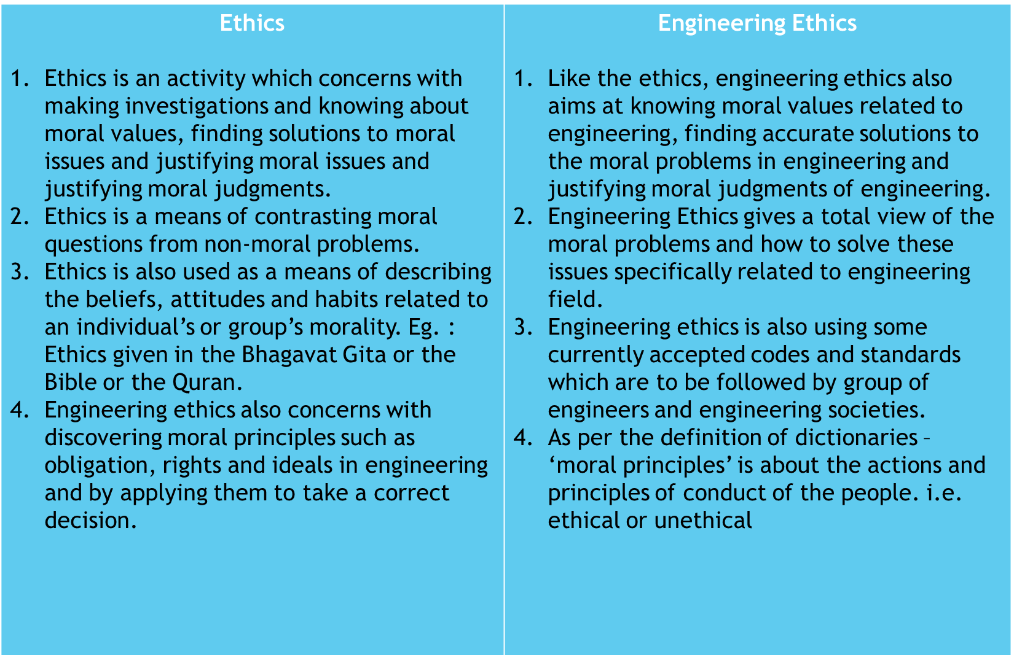

Engineering Ethics is the set of rules and guidelines that engineers adhere to as a moral obligation to their profession and to the world.

Engineering is a professional career that impacts lives. Engineers “ require honesty, impartiality, fairness, and equity, and must be dedicated to the protection of the public health, safety, and welfare.”

Engineering Ethics applies to every engineer and is very important.

Engineering ethics is (1) the study of moral issues and decisions confronting individuals and organizations involved in engineering and (2) the study of related questions about moral conduct, character, ideals and relationships of peoples and organizations involved in technological development.”— Martin

**Senses of Engineering Ethics**

The word ‘ethics’ has distinct several but related meanings. Below described are the four additional senses of the expression ‘Engineering Ethics’.

* ***Ethics*** is an activity and area of inquiry. It is the activity of understanding, resolving and justifying moral judgments. In a parallel manner, Engineering Ethics is the activity and discipline that is targeted to guide engineering practice, resolving moral issues in engineering and justifying moral judgments concerning engineering.
* ***Ethical problems*** are different from non-moral problems. Here the word ‘Ethical’ marks a sharp contrast between moral questions and questions of political, legal or artistic issues. Engineering Ethics in this sense refer to the set of problems that is specifically related with engineering arena.
* ***Engineering Ethics*** is a purely factual matter about what is good or bad in engineering profession. It is a distinct discipline in which engineers might be interested where they can observe, describe and explain different incidents and relate those issues with existing ethical context.
* ***Engineering Ethics*** aim to establish a set of justified moral principles related purely with engineering matters. Discovering such principles and applying them in concrete situations is the central goal of Engineering Ethics.

**Senses of Engineering**

* Using codes of ethics and standards and applying them in their transactions by engineers.
* There are **two different senses** (meanings) of engineering ethics, namely the ***Descriptive and the Normative senses***
* The ***Descriptive sense*** refers to what specific individual or group of engineers believe an act, without justifying their beliefs or actions.
* The ***Normative sense*** refers to knowing moral values, finding accurate solutions to moral problems and justifying moral judgments in engineering practices
* The ***main difference between normative ethics and descriptive ethics***
* normative ethics analyses how people ought to act
* descriptive ethics analyses what people think is right.

***The normative sense includes :***

* Knowing moral values, finding accurate solutions to moral problems and justifying moral judgments in engineering practices
* Study of decisions, policies, and values that are morally desirable in the engineering practice and research

***Variety of Moral Issues***

* A moral issue can be understood as an issue to be resolved not only by considering the technical stuff but also by keeping moral values in mind
* “Moral issue is a working definition of an issue of moral concern as is presented in any issue with the potential to help or harm anyone, including oneself.”
* There are mainly ***two types of Moral issues***
* ***Micro-ethics :*** This approach stresses more on the problems that occur on a daily basis in the field of engineering and its practice by engineers.
* ***Macro-ethics :*** This approach deals with social problems which are unknown. However, these problems may unexpectedly face the heat at both regional and national levels.

***Types of Inquiries***

* The issues can be resolved by following an investigation procedure, step by step in order to have a clear understanding towards the issue. Here we have three different types of inquiries.
* Judging the issues has to be followed by a systematic procedure to avoid any flaws. Engineering ethics involves investigations into values, meanings and facts.
* Following are the different types of inquiries made for this:
* Normative inquiries
* Conceptual inquiries
* Factual or descriptive inquiries

**Normative Inquiry**

* It seeks to identify and justify the morally-desirable norms or standards that should guide individuals and groups
* It also has the theoretical goal of justifying particular moral judgments
* Normative questions are about what ought to be and what is good, based on moral values
* How far does the obligation of engineers to protect public safety extend in any given situation?
* When, if ever, should engineers be expected to blow whistle on dangerous practices of their employers?
* Whose values ought to be primary in making judgment about acceptable risks in design for a public transport system or a nuclear plant?
* Is it of management, senior engineers, government, engineers’ associations or all of them?
* Normative Inquiry refers to the description that describes what one ought to do under a specific circumstance.
* This is the expected ideal response, which might differ from what one believes to be right or wrong.
* This list identifies and justifies the morally desirable nature for guiding individuals or groups.
* Responsibility of engineers to protect the public safety and how they should respond under such dangerous practices
* Quote the laws and procedures that affect the engineering practice on moral grounds
* Refer to the thought process where the moral rights are to be implemented in order to fulfill their professional obligations

**Conceptual Inquiries**

* It is directed to clarify the meaning of concepts or ideas or principles that are expressed by words or by questions and statements.
* What is meant by safety?
* How is it related to risk?
* What is a bribe?
* What is a profession?
* When moral concepts are discussed, normative and conceptual issues are closely interconnected

**Factual and Descriptive Inquiries**

* Factual Inquiry or the descriptive inquiry help to provide the facts for understanding and finding solutions to the value based issues
* The engineer has to conduct factual inquiries by using scientific techniques.
* This helps in providing the information regarding the business realities such as engineering practice, history of engineering profession, the effectiveness of professional societies, the procedures to be adopted when assessing risks and psychological profiles of engineers

**LECTURE-9 : Moral Dilemmas , Moral Autonomy**

**Moral Dilemmas**

* Dilemmas are situations in which moral reasons come into conflict, or in which the application of moral values are problems, and one is not clear of the immediate choice or solution of the problems
* Moral reasons could be rights, duties, goods or obligations. These situations do not mean that things had gone wrong, but they only indicate the presence of moral complexity.
* This makes the decision making complex.

**For example:** A person promised to meet a friend and dine, but he has to help his uncle who is involved in an accident — one has to fix the priority.

***There are some difficulties in arriving at the solution to the problems, in dilemma. The three complex situations leading to moral dilemmas are****:*

1. 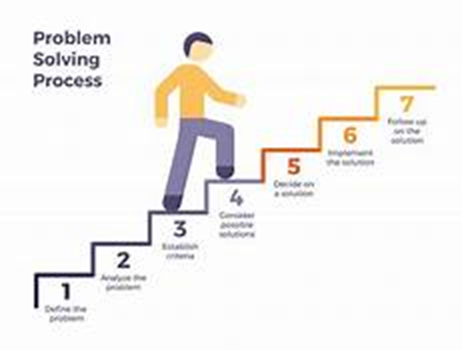***The problem of vagueness:*** One is unable to distinguish between good and bad (right or wrong) principle. Good means an action that is obligatory. For example, code of ethics specifies that one should obey the laws and follow standards. Refuse bribe or accept the gift, and maintain confidentiality
2. ***The problem of conflicting reasons:*** One is unable to choose between two good moral solutions. One has to fix priority, through knowledge or value system.
3. ***The problem of disagreement:*** There may be two or more solutions and none of them mandatory. These solutions may be better or worse in some respects but not in all aspects. One has to interpret, apply different morally acceptable reasons, and analyze and rank the decisions.

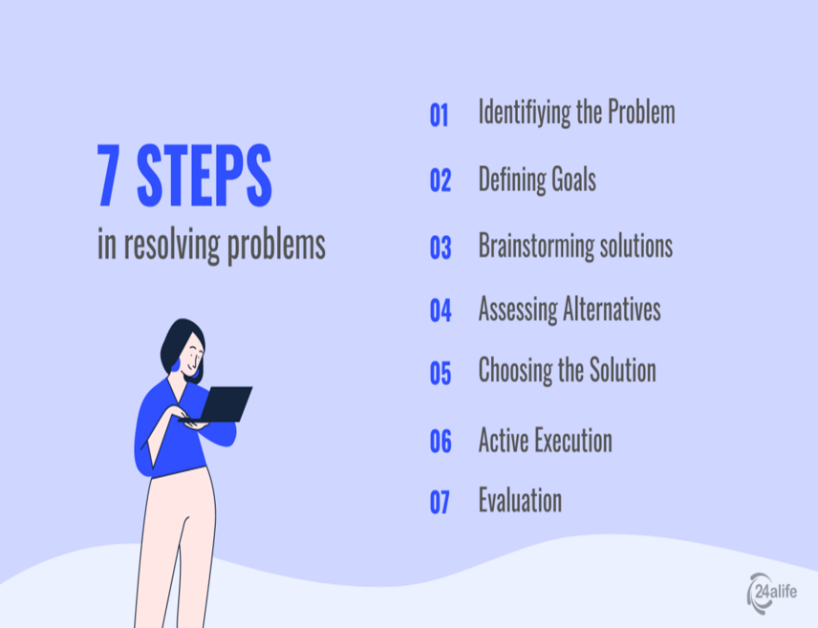

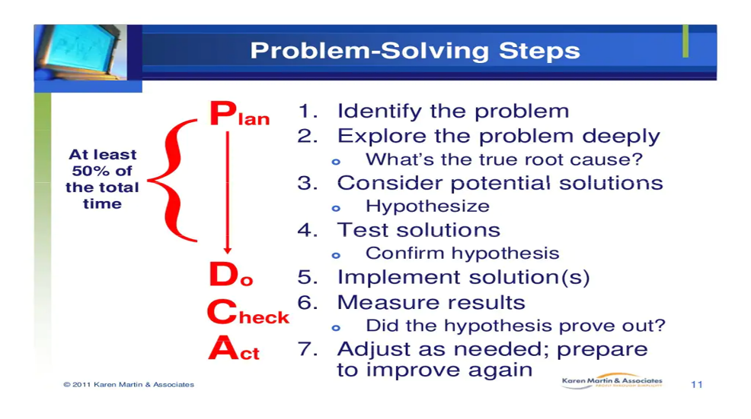**Steps to Solve Dilemma**

The logical steps in confronting moral dilemma are:

1. ***Identification of the moral factors and reasons:***

* The clarity to identify the relevant moral values from among duties, rights, goods and obligations is obtained (conceptual inquiry).
* The most useful resource in identifying dilemmas in engineering is the professional codes of ethics, as interpreted by the professional experience.
* Another resource is talking with colleagues who can focus or narrow down the choice of values.

1. ***Collection of all information:*** data, and facts (factual inquiry) relevant to the situation
2. ***Rank the moral options:***

* Prioritize the options
* Obligatory, acceptable, not acceptable,
* Consequences**:** damaging, and most damaging etc.

**For example**, in fulfilling responsibility, the codes give prime importance to public safety and protection of the environment, as compared to the individuals or the employers (conceptual inquiry).

1. ***Generate alternate courses of action*** to resolve the dilemma. Write down the main options and sub-options as a matrix or decision tree to ensure that all options are included
2. ***Discuss with colleagues*** and obtain their perspectives, priorities, and suggestions on various alternatives
3. ***Decide upon a final course of action***, based on priority fixed or assumed. If there is no ideal solution, we arrive at a partially satisfactory or ‘satisficing’ solution

**Moral Autonomy**

* Moral autonomy is the decisions and actions exercised on the basis of moral concern for other people and recognition of good moral reasons.
* Alternatively, moral autonomy means ‘self determinant or independent’.
* The autonomous people hold moral beliefs and attitudes based on their critical reflection rather than on passive adoption of the conventions of the society or profession.
* Moral autonomy may also be defined as a skill and habit of thinking rationally about the ethical issues, on the basis of moral concern

***The engineering skills related to moral autonomy are listed as follows:***

1. Proficiency in recognizing moral problems in engineering and ability to distinguish as well as relate them to problems in law, economics, and religion
2. Skill in comprehending, clarifying, and critically-assessing arguments on different aspects of moral issues
3. Ability to form consistent and comprehensive view points based on facts
4. Awareness of alternate responses to the issues and creative solutions for practical difficulties
5. Sensitivity to genuine difficulties and subtleties, including willingness to undergo and tolerate some uncertainty while making decisions
6. Using rational dialogue in resolving moral conflicts and developing tolerance of different perspectives among morally reasonable people
7. Maintaining moral integrity

* ***Autonomy,*** which is the independence in making decisions and actions, is different from authority.
* ***Authority*** provides freedom for action, specified within limits, depending on the situation.
* Moral autonomy and respect for authority can coexist. They are not against each other.
* If the authority of the engineer and the moral autonomy of the operator are in conflict, a consensus is obtained by the two, upon discussion and mutual understanding of their limits

**LECTURE-10 : Kohlberg's theory, Gilligan's theory**

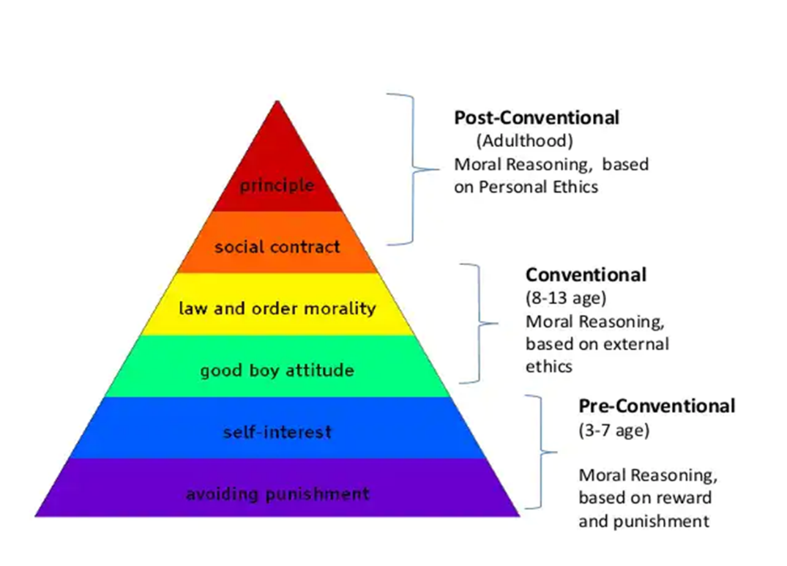***Kohlberg's theory***

***Kohlberg's theory of Moral Development***

* Kohlberg's theory is based on the foundation that morality is a form of reasoning that develops in structural stages.
* According to him, the people progressed in their moral reasoning through a series of stages.
* These stages are pre-conventional, conventional, and post-conventional
* 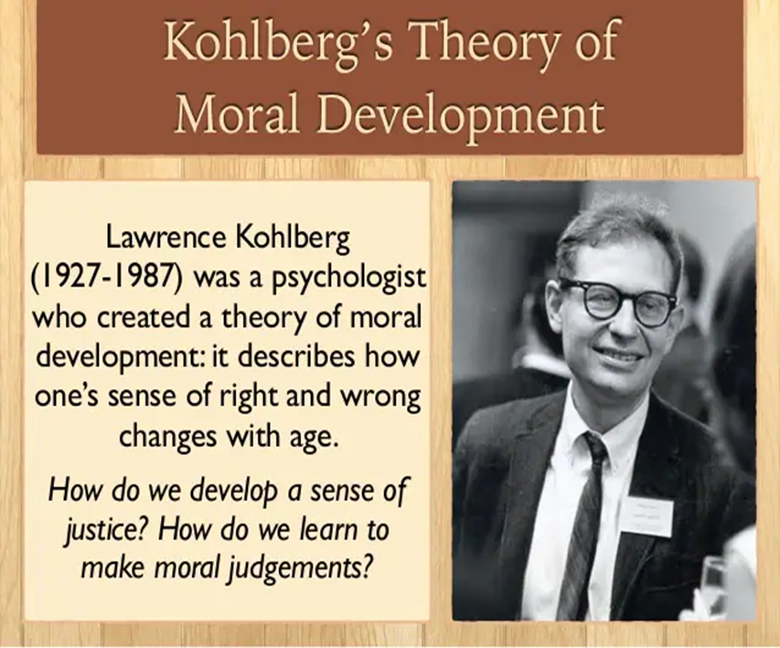These stages are based on the type of reasoning and motivation of the individuals in response to moral questions

***Pre- conventional level***

* The pre-conventional level of moral development is based to derive benefits for oneself.
* 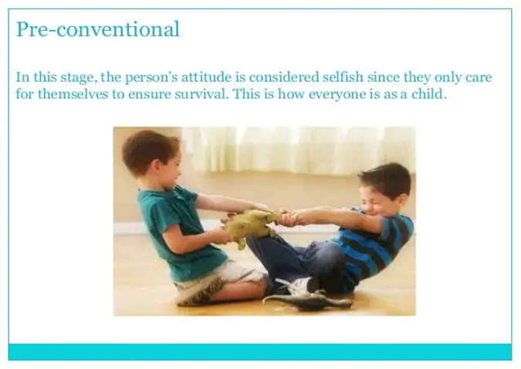In the first level, individuals behave according to socially acceptable norms, which are taught mainly by parents and teachers.
* 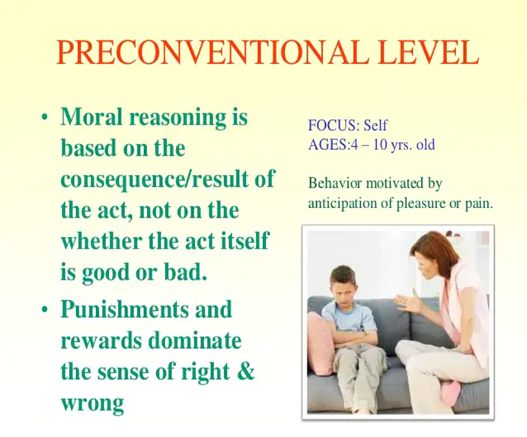At this level, individuals are motivated mainly by their interest to avoid punishment, or by their desire to satisfy their own needs, or by the external power exerted on them.
* This is the level of development of all young children and some adults, who are unable to reach beyond a certain limit.

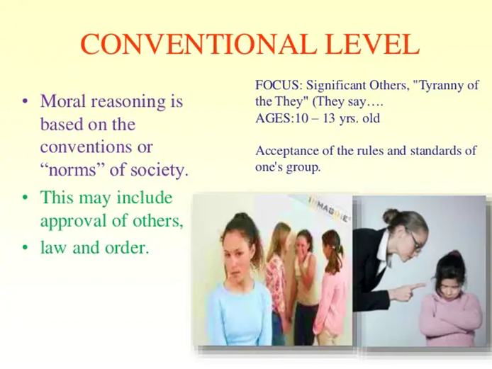***Conventional level***

* The moral thinking and behavior of the individual are determined by the standards of their family, community, and society. That is, the norms or customs of one‘s family/community/society are accepted and adopted as the ultimate standard of morality.
* 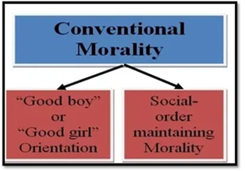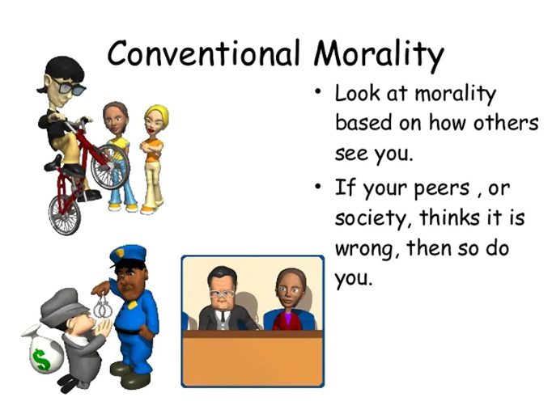At this level, individuals are motivated by the desire to please others and to meet the social units’ expectations, without bothering much about their self-interest.
* Thus as per the second level, individuals give more importance to loyalty and close identification with others, than their own self-interest.
* Many studies of Kohlberg reveal that most adults are living at this level only.
* The second level of moral thinking is found in society generally. That‘s why it is named as ‘conventional’ level of moral development

***Post-Conventional Level***

* 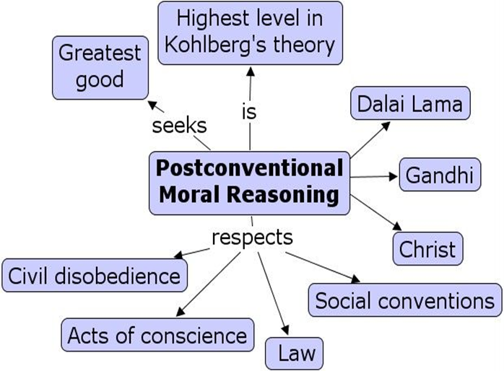In the post-conventional level, the individuals are guided by strong principles and convictions, not by selfish needs or pressures from society.
* According to Kohlberg, these individuals are called as ‘autonomous’, because they think for/by themselves and also they do not believe that customs are always right.
* The people at this level want to live by general principles that are universally applied to all people. They always desire to maintain their moral integrity
* Kohlberg felt that the majority of adults do not reach the post-conventional level.

***Gilligan's theory of Moral Development***

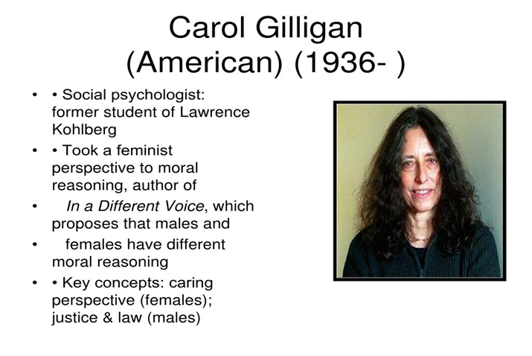Carol Gilligan, a former student and colleague of Kohlberg, has criticized Kohlberg‘s theory as male biased.

According to Gilligan, males have tendency to over-ride the importance of moral rules and convictions while resolving moral dilemmas; whereas females have tendency to try hard to preserve personal relationships with all people involved in a situation.

Also Gilligan felt that men mostly focus their attention on content of the problem, whereas women focus their attention on the context i.e., situation of the problem.

Gilligan refers her context-oriented emphasis on maintaining personal relationships as the ethics of care, and contrasts it with Kohlberg‘s ethics of rules and rights

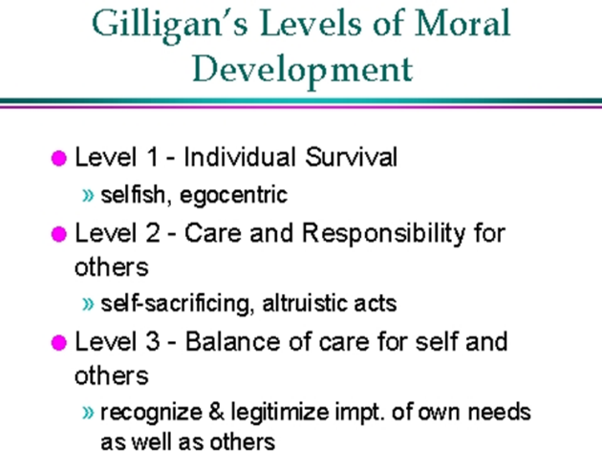***Gilligan’s Levels Of Moral Development***

***Pre-conventional level***

* This is almost the same as Kohlberg‘s first level.
* That is, in this level an individual is concerned with self-centered reasoning.

***Conventional level***

* This level differs from Kohlberg‘s second level.
* 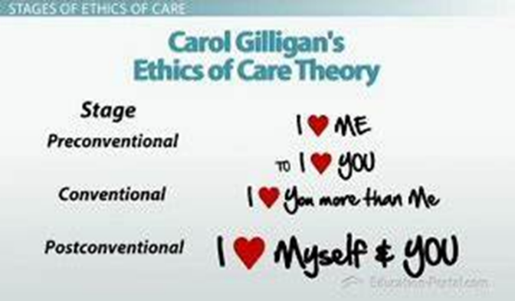According to Gilligan, women will not hurt others and have a willingness to sacrifice their own interests in order to help others.

***Post-conventional level***

* This level also differs from Kohlberg‘s third level.
* In this level, the individual is able to maintain balance between his own needs with the needs of others.
* The balancing can be achieved through context-oriented reasoning i.e., examining all facts, people and circumstances involved, rather than by applying abstract rules ranked in a hierarchy of importance.

